Introducing the Dot Plot Custom Visual

We are excited to announce a new custom visual: Dot Plot. Create straightforward charts that highlight gaps, clusters, and outliers by plotting individual data points on a simple scale. Many data visualization experts, including Stephen Few, consider the dot plot one of the most useful chart types. Dot Plot’s simplicity is particularly helpful when you’re working with medium or small data sets.

Imagine a scenario in which you need to show the distributions of individual values across categories. You may need to track how a group of students performed on a series of tests. Or you may want to visualize a movie’s ratings across defined populations. Dot chart is your perfect solution whenever you need to generate insightful and effective comparisons.

Let’s see Dot Plot in action. In the visual below, each dot represents a state’s annual sales data. States in red need attention, and states in blue performed well. The dots’ sizes provide additional information on states’ gross margins, offering opportunities to dig deeper into the root causes of successes and failures.

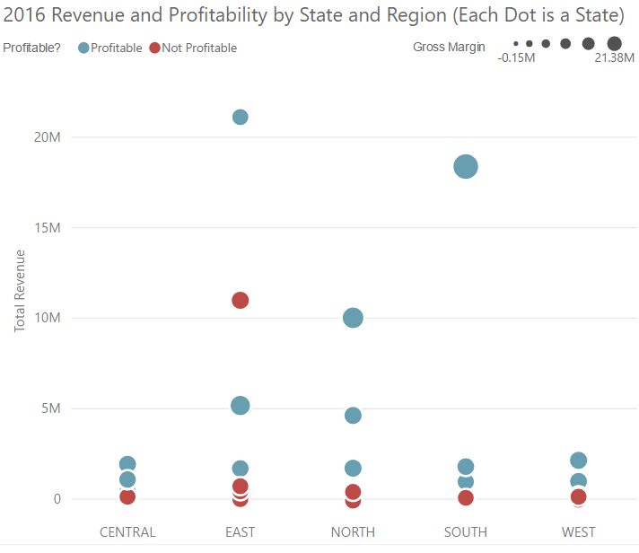

But wait. What if digging deeper means looking at states’ seasonal performance? No problem. Simply drag the quarter field to the view to analyze the data at a seasonal level.

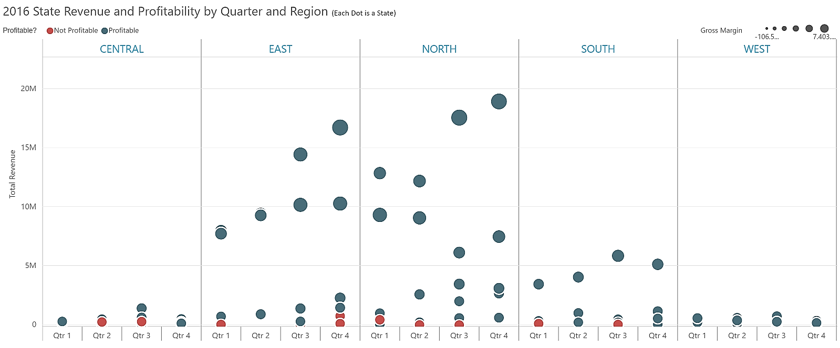

Love the insights in this view? Now let’s see how you can perform additional formatting and refinement to reflect your personal style and preferences. Here is our formatting pane, where you can find many fun formatting options, including view orientations, split labels, background shading, gridline customization, and bubble colors.

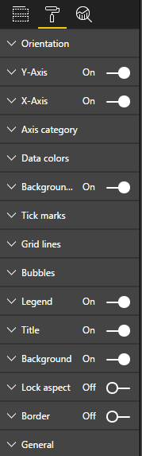

Let’s look at formatting options one by one:

1. In ‘horizontal’ orientation, the orientation of Y axis labels and Parent labels can be flipped.
2. Formatting options for Y axis: Title, title text, Title color, Title font size, labels, display units and decimal points can be updated. The Y-axis start, and end values can be changed, so no magnitude comparison can be done, without having to start the y-axis from 0.
3. Similar options are available for X-axis. Also, minimum width of each X axis label can be configured. After updating the width if the labels cannot be accommodated, horizontal scroll bar appears.
4. Using ‘Axis category’ settings, Axis category II labels can be flipped from top to bottom. The color and font size also can be updated. In case of ‘Horizontal’ orientation, Axis category II labels can be flipped from right to left.
5. The background, axis and category color of graph can be modified along with the transparency.
6. The axis and category tick marks can be shown or hidden. The color, thickness of axis and category tick marks can be updated. Similar options are available for grid lines as well.
7. The color, minimum and maximum size radius, border, and transparency of the bubble can be modified according to the category.
8. Legend positions, font color, font size, title color, title text can be updated. The color, display units and decimal places of size legends can be updated.
9. If a measure is selected instead of category in ‘Legend’ field, legend disappears and Gradient colors option will appear. The color of each bubble will be a different gradient ranging from minimum color to maximum color provided in the ‘Gradient colors’ option.

Thanks for watching this video. This custom visual is a joint effort by MAQ and Miranda Li – Data Visualization Lead at Microsoft. If you have any questions about this visual, you can contact MAQ Software at [sales@maqsoftware.com](mailto:sales@maqsoftware.com) or Miranda Li.